**Department of Computer Science**

**Question 1/Task 1:**

**Answer**

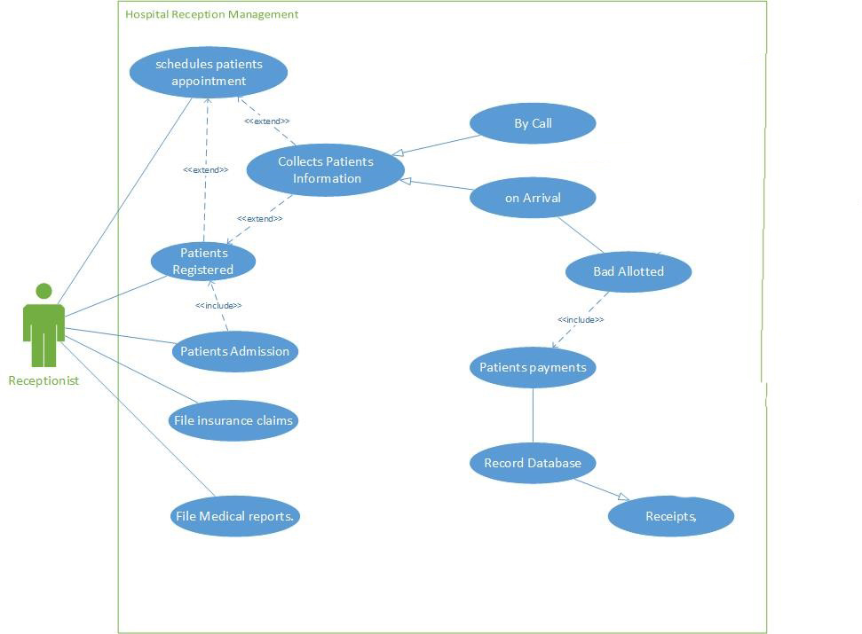

**Question 2/Task 2:**

**Answer:**

